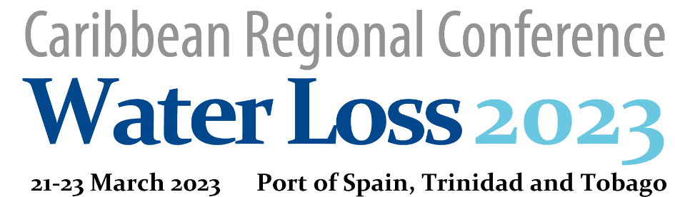

CALL FOR ABSTRACTS

About the Conference
The Regional Caribbean Water Loss 2023 conference in Trinidad and Tobago is the first ever Specialized Water Loss Conference in the Caribbean. It attends to address the needs of water utilities in the Caribbean, who are under pressure to significantly and sustainably reduce water losses (and thus carbon emissions) during the next seven years. The conference is expected to attract about 150 participants from the region. In addition, some of the world’s leading experts in the field of Non-Revenue Water Management are expected to attend, and will discuss the latest developments, strategies, techniques and applications of international best practices and their applicability to the Caribbean.
These ten main topics which will be discussed during the conference are:
- Combating climate change through NRW reduction
- NRW assessment and strategy design
- Leak detection technologies, strategies, equipment
- Network zoning and DMA design
- Pressure monitoring and management
- Water metering
- Performance based NRW management contracts
- Organizational and institutional issues
- Economics and financing
- Capacity building and human resource issues

Call for abstracts
Authors are encouraged to present papers dealing with any water loss reduction related topic. The aim is to provide a comprehensive programme of the highest quality, reflecting a wide range of international experiences.
You are invited to submit an extended abstract (500 – 1,000 words, including figures, diagrams, or illustrations, using the template on the next pages) in pdf format. Please headline your abstract with the following information:
- Topic (choose one from the list, #1 - #10)
- Title of presentation
- Author’s name and affiliation, email address (if several authors, highlight corresponding author)
- Presenting author’s country (country where the author is based)
Proposals (topics) for workshops or panel discussions can also be submitted. Please indicate if you like to design and manage the workshop/discussion or it is just a suggestion for the WLSG to organize and find the most appropriate speakers.
Please upload abstract to: https://mpu.gov.tt/crwlc2023/submit-papers
or email to: abstracts.crwlc2023@mpu.gov.tt

Deadline for the submission of abstracts: 8th January 2023
ABSTRACT TEMPLATE AND INSTRUCTIONS

Topic (choose one from the list, #1 - #10):

Title of presentation:

Author(s)
Author Name*, Author Name**, initials then surnames, separated by commas, if more than one author, the CORRESPONDING AUTHOR shall be the first
*This is the first author’s affiliation and email
**This is the second author’s affiliation and email

Country
Presenting author’s country (country where the author is based)

Suggested format of presentation/event
Poster presentation
Oral presentation
Workshop
Panel Discussion
If workshop or panel discussion, please indicate:
I’m ready to design and manage the workshop/discussion and have the speakers
It is just a suggestion for the WLSG which would need to organize, manage and find the most appropriate speakers
ABSTRACT
Summary
Summarize content of the suggested presentation/event. 100 – 300 words
Findings and Conclusions
What are the main findings/conclusions? 200 – 500 words
Importance
Explain why your abstract should be accepted and how the conference delegates could benefit from it. Up to 200 words

INSTRUCTIONS
Format
The abstract may also include tables, charts and pictures.
Paper Size: A4 (and not letter). Margins: Left: 2.5 cm, Right, Top and Bottom: 1.5 cm.
Page numbering as in this template.
Units to be used
In general, international units (m, m3, litres) shall be used. US or Imperial units might be added as additional information: for example: the daily water production is 200,000 m³ (52.88 million US gallons). The same applies to length (kilometres) and pressure (m pressure).
Abbreviations and Performance Indicators
Always use international standard abbreviations and performance indicators
For example, if, for any reason, you use % real losses or %NRW, add also more meaningful performance indicators
Currency
When using local currency amounts always also provide the USD equivalent.

